Column 1

* Technology:

<https://www.stuff.co.nz/business/world/300372003/twitter-founder-jack-dorseys-square-to-buy-afterpay-for-41-billion>



* Technology

<https://www.stuff.co.nz/sport/olympics/125862360/tokyo-olympics-robot-sinks-threepointer-and-half-court-shots-during-halftime-break>

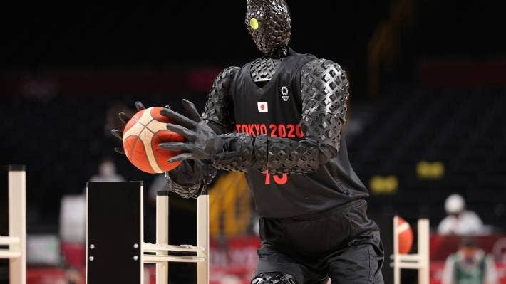

* Sports

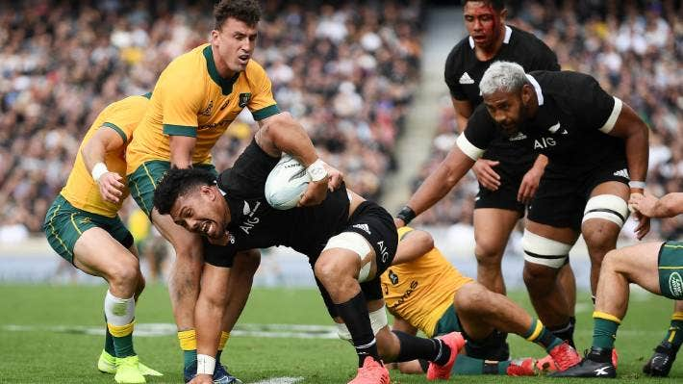<https://www.stuff.co.nz/sport/rugby/all-blacks/300373026/no-all-blacks-tests-in-wellington-as-matches-shifted-to-auckland-and-perth\>

- Sports

<https://www.stuff.co.nz/sport/olympics/125955512/tokyo-olympics-peter-burling-and-blair-tuke-have-to-settle-for-silver-medal>

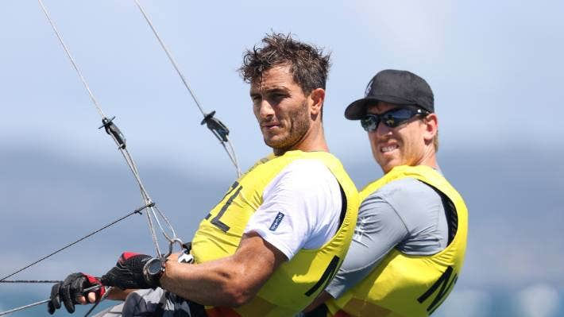

-Travel

<https://www.stuff.co.nz/travel/destinations/europe/france/300373105/giant-panda-in-french-zoo-gives-birth-to-lively-twin-girls>

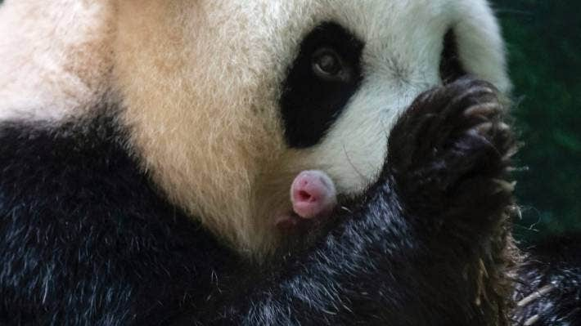

* Travel

<https://www.stuff.co.nz/travel/experiences/cruises/125940487/no-kids-allowed-where-adults-can-escape-from-the-nippers-on-disneys-new-ship>



Column 2

* Middle east

<https://www.stuff.co.nz/national/99646528/nz-forces-could-remain-in-middle-east-in-ongoing-battle-against-isis>



* Middle East

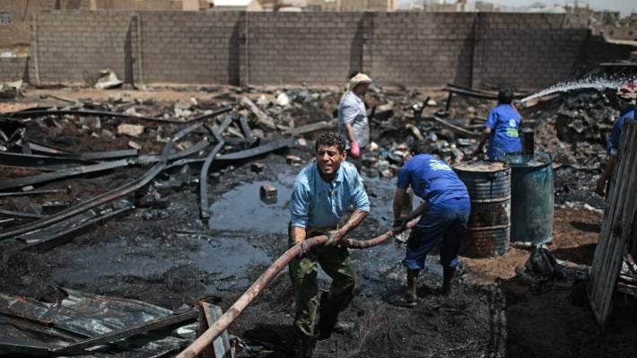[https://www.stuff.co.nz/world/middle-east/124222203/understanding-the-crisis-in-yemen- starving-children-and-the-middle-eastxs-cold-war](https://www.stuff.co.nz/world/middle-east/124222203/understanding-the-crisis-in-yemen-%09starving-children-and-the-middle-eastxs-cold-war)

* Business

<https://www.stuff.co.nz/environment/125907444/dairy-companies-and-volunteers-dig-deep-to-help-restore-waterways-and-bat-colony>

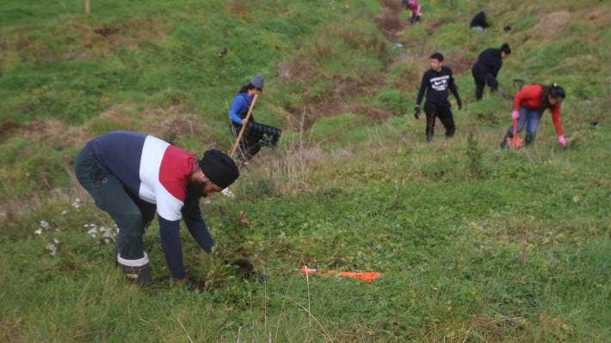

* Business

<https://www.stuff.co.nz/the-press/business/125951794/roadworks-hammer-shops-and-force-florist-to-open-popup-to-stay-afloat>

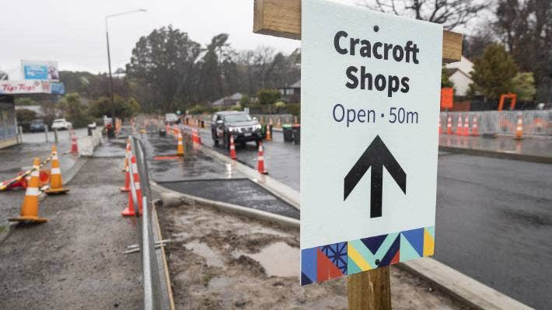

Column 3